Is it a Tree?

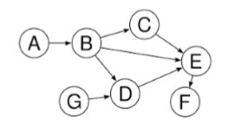Directed graph and multiple edges are given as a single component. Determine whether the graph is a tree or not. In this case, it is required to determine if the graph is a cyclic graph (Contains Cycles) which contains a path from at least one node back to itself, see **the figures below.**

**Is a Tree Graph**

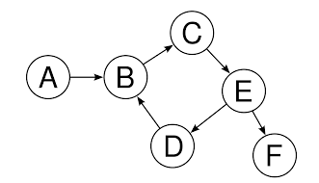

**Is NOT a Tree**

I want you to implement IsTree function to return true or false.

Your function has vertices array (1 ≤ size ≤ 100,000) in the graph and edges as a list of KeyValuePair.

## Example

3 // Vertices Count

4 // Edges Count

A1,A2,A3 // Vertices

A1,A2 // Edges

A2,A1

A2,A3

A3,A2

true // IsTree

## Requirement Implementation

Implement the following isTree function to return true or false as a description for the given graph.

static bool IsTree(string[] vertices, List<KeyValuePair<string, string>> edges)

# C# Help

If you need any help regarding the syntax of C#, **ask any TA**.

## Sorting single array

Sort the given array in ascending order

Array.Sort(items);

## Sorting parallel arrays

Sort the first array "master" and re-order the 2nd array "slave" according to this sorting

Array.Sort(master, slave);

## Creating 1D array

int [] array = new int [size]

## Creating 2D array

int [,] array = new int [size1, size2]